1. a i) create table Student(s_id varchar(6), s_name varchar(20), sex char, dob date,dep_no int, primary key(s_id));

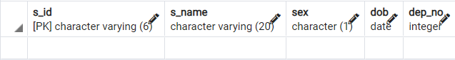

a ii) create table Department(dep_no int, dep_name varchar(3),primary key(dep_no));



a iii) create table Faculty(f_id varchar(4), f_name varchar(20), designation varchar(20), salary float,dep_no int,primary key(f_id));



a iv) create table Course(c_id varchar(4), c_name varchar(20), credits int,dep_no int,primary key(c_id));

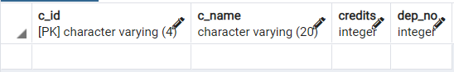

a v) create table Register(s_id varchar(6),c_id varchar(4),sem int);



a vi) create table Teaching(f_id varchar(4),c_id varchar(4),sem int,primary key(f_id));

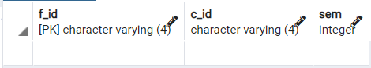

a vii) create table Hostel(h_id varchar(3),h_name varchar(20),no_rooms int, primary key(h_id));

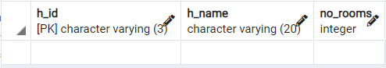

b)

insert into Student values

('CSE101','Anand','M','20-10-2004',1),

('ECE161','Viji','F','02-03-2005',2);

insert into Department values

(1,'CSE'),

(2,'ECE');

insert into Faculty(f_id,f_name,designation,dep_no) values

('F131','Arun','Assistant Professor',3),

('F254','devi','Lecturer',2);

insert into Course values

('E001','Digital Electronics',3,2),

('C321','DBMS',4,1);

insert into Register values

('CSE101','C321',4),

('ECE133','E001',3);

insert into Teaching values

('F131','C321',4),

('F254','E001',3);

insert into Hostel values

('H01','Ganga',100),

('H02','Yamuna',200);

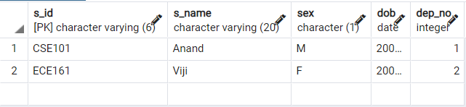

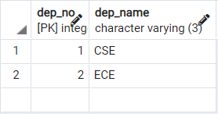

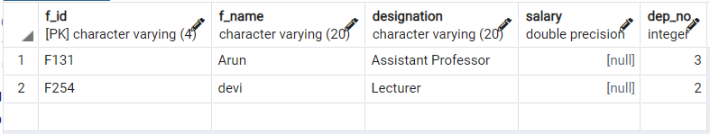

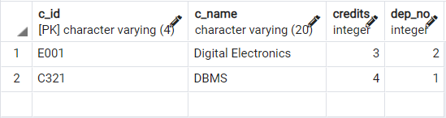

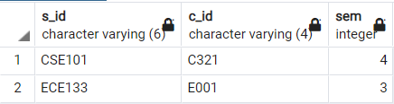

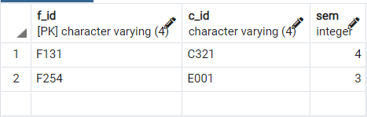

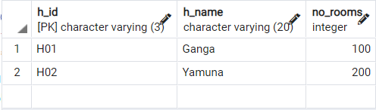

c)

insert into Student values

('CSE102','Aadithyan','M','28-03-2002',1),

('ECE162','Aravind','M','06-07-2003',3),

('CSE306','Akhila','F','08-10-2003',1),

('ECE163','Madhav','M','16-05-2002',4),

('CSE162','Santosh','M','20-02-2002',5);

insert into Department values

(6,'ELC'),

(7,'EAC'),

(3,'AIE'),

(4,'EEE'),

(5,'MEE');

insert into Faculty(f_id,f_name,designation,dep_no) values

('F132','Ani','Professor',5),

('F255','Mini','Lecturer',4),

('F133','Ashwin','Assistant Professor',3),

('F256','Mathew','Lecturer',1),

('F137','Lal','Assistant Professor',2);

insert into Course values

('M002','AUTOCAD',3,5),

('C001','Python',4,1),

('M001','Drawing',3,5),

('C300','C++',4,1),

('C100','Java',4,1);

insert into Register values

('CSE102','C001',1),

('ECE162','M002',3),

('CSE306','C300',1),

('ECE163','M001',4),

('CSE162','C001',5);

insert into Teaching values

('F132','M002',5),

('F255','M001',4),

('F133','C001',3),

('F256','C100',1),

('F137','C300',2);

insert into Hostel values

('H03','Brahmaputra',300),

('H04','Mahanadi',400),

('H05','Narmada',500),

('H06','Godavari',600),

('H07','Tapi',700);

d.

Select * from Student;

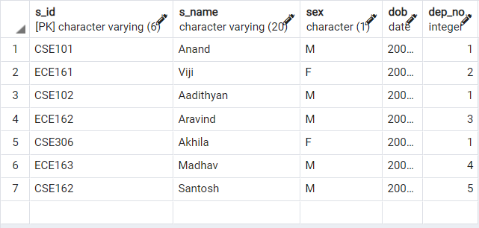

Select * from Department;

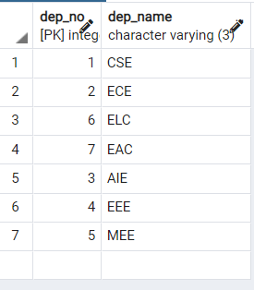

Select * from Faculty;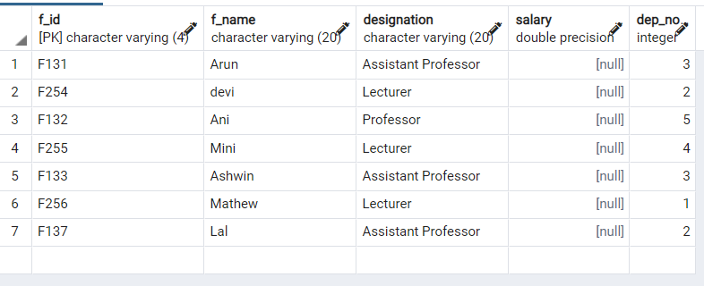

Select * from Course;

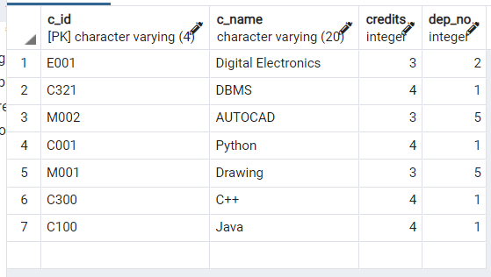

Select * from Register;

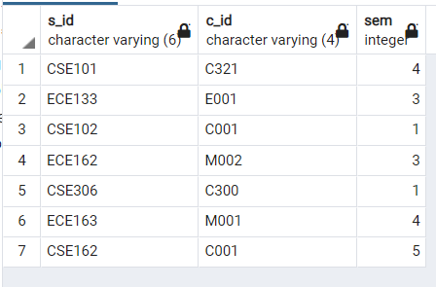

Select * from Teaching;

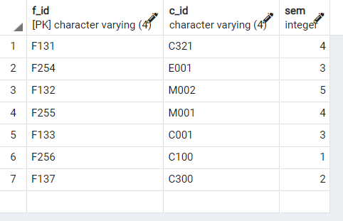

Select * from Hostel;

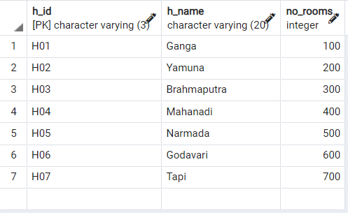

e)

drop table Hostel;

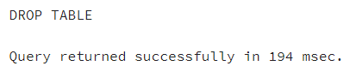

2

a.

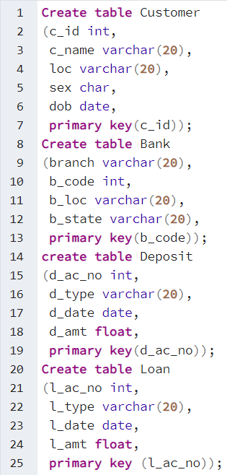

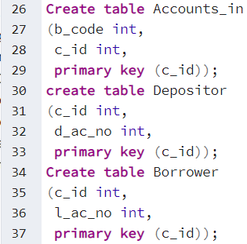

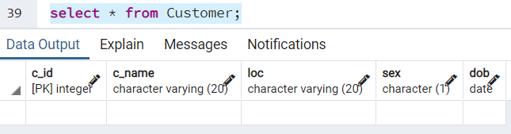

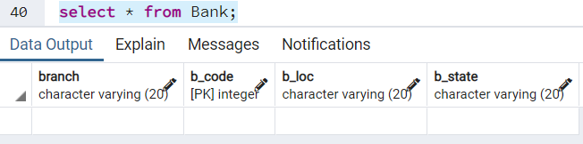

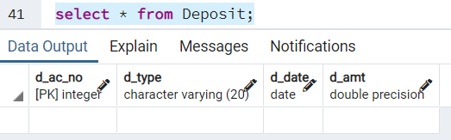

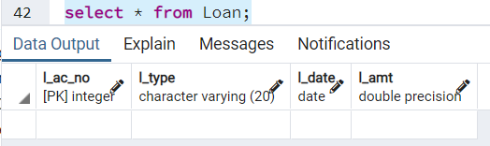

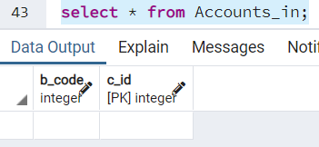

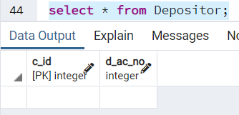

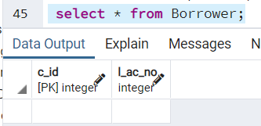

b)

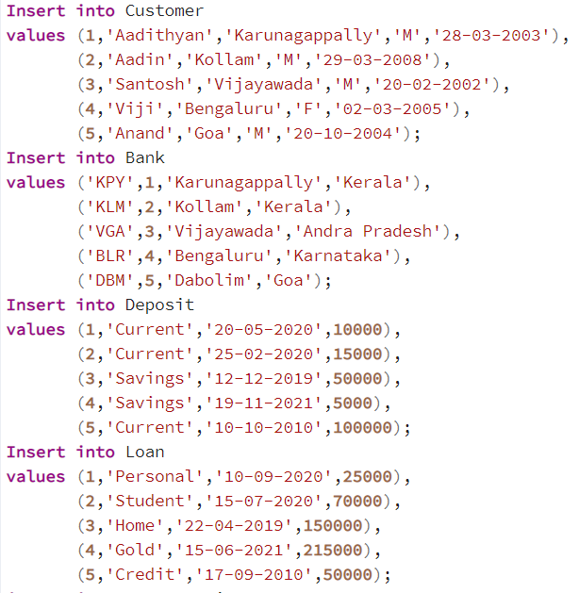

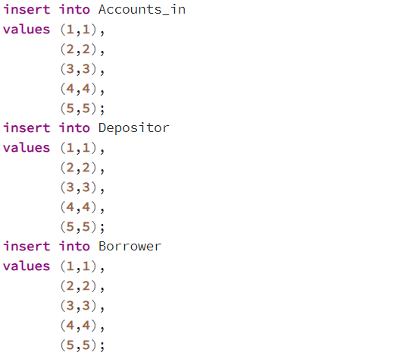

c)

